Project 2 – Fun with Warehouses

Release: 28 Oct 2017 (Sat, week 10)

Due: 11 Nov2017 (Sat, week 12) 23:30 hrs.

Warning:
- We view plagiarism very seriously. You MUST acknowledge all 3rd-party code used, reference sources or assistance obtained. Submit the acknowledgement/references used (if any) to eLearn dropbox as a word/PDF document or text file by the deadline. Detected plagiarism cases will be escalated to the Dean’s Office.

Instructions:
- There are three questions in this assignment to be completed in pre-assigned teams of three.
- Each team is required to (i) submit code for each question, and (ii) make a short presentation in class during week 13.
- Any member of a team may submit on behalf of the team. Be aware that it is possible for your team member to “overwrite” your submission by submitting a file of the same name. You can submit your solutions to the server as many times as you wish, but the final submission (by any member) on the deadline will be taken as your team’s final submission.
- Each team is collectively responsible for its submission, and each member should contribute to the team effort (This is a good opportunity to practice good teamwork). Do escalate all “team member problems” to your instructor ASAP for early intervention.
- A team score will be given but an individual’s score may differ from the team’s score in special cases. Students will be required to complete a peer appraisal after the presentation.

The Grandmother’s Story…

Continuing with the story in your first assignment, Amazon has decided to build a warehouse at Yishun. Here is how the shelf for goods look like at the warehouse:

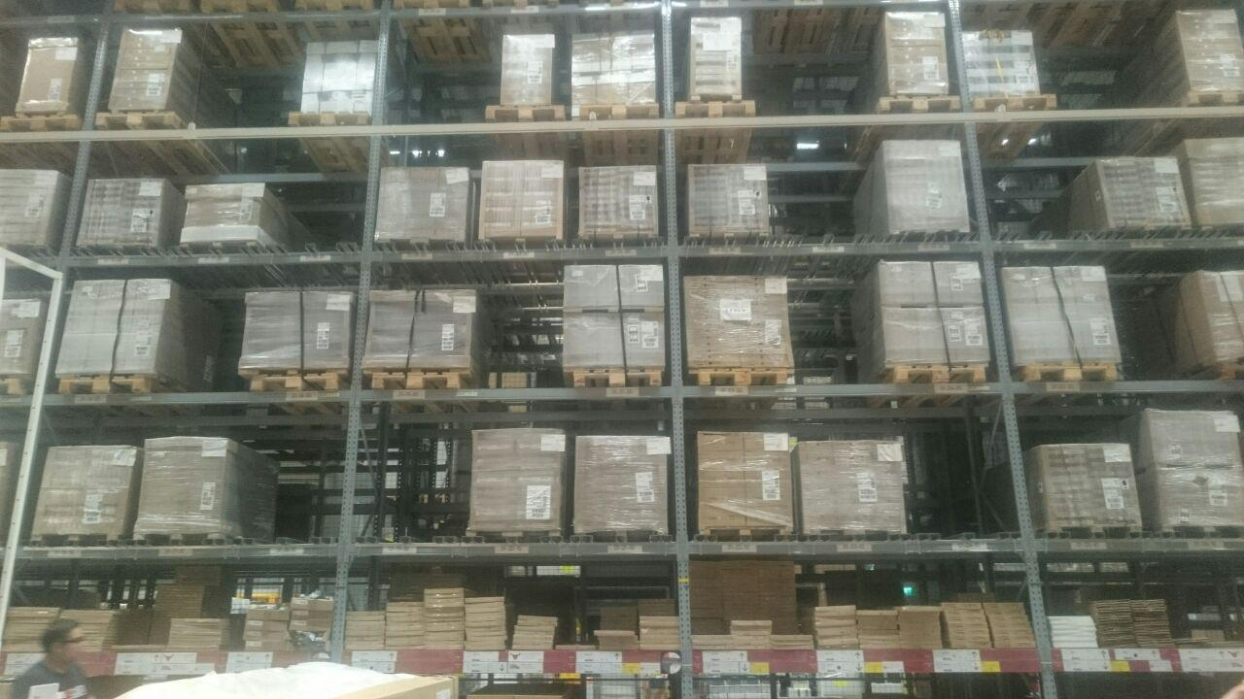

Items are placed in identical squarish cells in a huge rectangular array:
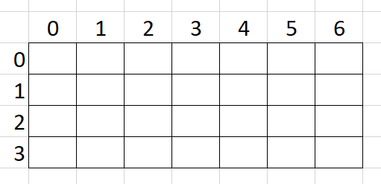
The position of each cell is indicated by its row and column like this: [row][column]. Each cell stores only one type of items. You can assume that items will never run out in each cell.

There is a robot arm that starts at the upper-left corner ([0][0]) and moves about to collect items from cells. (The special cell [0][0] will henceforth be called the “origin”.) The robot arm moves at a constant speed in any direction. Hence, the total time required for the robot to move between cells is equivalent to the total distance moved between cells. You can easily calculate the distance moved between two cells using geometry.
e.g. to move from [2][6] to [0][1]:
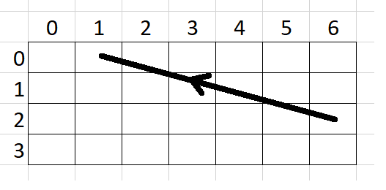
Euclidian distance moved by robot arm = d_{(2,6)-(0,1)} = √ ((6-1)² + (2-0)²) = 5.4 units

The arm always starts and ends at the origin, and is also is able to “store” all items collected. An “order” is a list of items that the arm will collect from the shelf. To fulfil an order of, say, “radish”, “watermelon” and “lemon” (in this particular sequence), the arm moves from the origin to the “radish” cell, then to the “watermelon” cell, and the “lemon” cell, before returning to the origin.

Q1:
The positions of each item on the shelf is fixed. You are given the item names in each cell (e.g. “lightsaber” is at [2][1], “durian” is at [2][4] etc.).
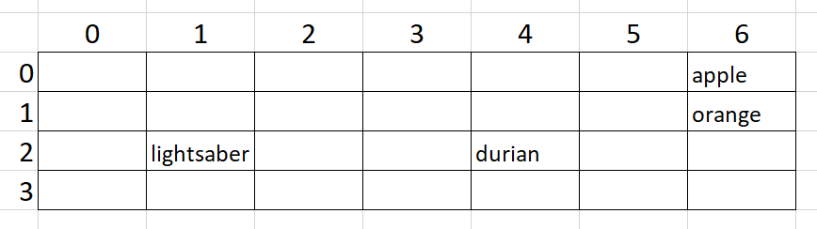
You are given an order (e.g. “lemon”, “apple”, “orange”....). Your algorithm is to propose a collection sequence for the items in the order for the robotic arm to follow, with the objective of minimizing the distance moved by the arm.

Method to write:
get_sequence(map, order)
where:
- map is a 2D array representing the positions of items on the shelf.
e.g. map = [["disc", "zebra", "apple"], ["pen", "mouse", nil], ["sofa", nil, "durian"], ["lightsaber", "horse", "pie"]]
represents the following layout:
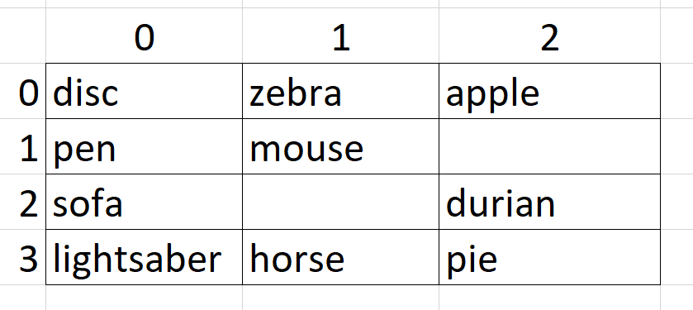
- order is a 1D array containing a list of items in an order.
e.g. order = ["horse", "apple", "durian", "zebra"]
Items will not be duplicated in order, and all items in the order will definitely be found on the shelf (i.e. exists in map). All items in the order must be collected. Item names are case-sensitive (i.e. "horse" is not the same as "Horse").
Your method should return the same order in the sequence that you want the robot to pick from the shelf, so that the robot moves as little as possible to fulfil the order.
e.g. get_sequence may return: ["zebra", "apple", "durian", "horse"]
Your quality score is the total distance moved by the robot using your proposed sequence (the smaller the better).

e.g. for the map given above, if get_sequence returns ["zebra", "apple", "durian", "horse"], the robot arm needs to move according to this diagram:
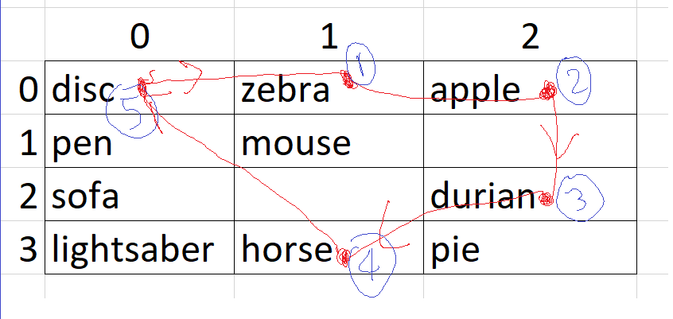
Total distance moved = d_{(0,0)-(0,1)} + d_{(1,0)-(0,2)} + d_{(0,2)-(2,2)} + d_{(2,2)-(3,1)} + d_{(3,1)-(0,0)}
= √ ((0-1)² + (0-0)²) + √ ((0-2)² + (1-0)²) + √ ((2-2)² + (0-2)²) + √ ((2-1)² + (2-3)²) + √ ((1-0)² + (3-0)²)

Rules:
- get_sequence must return a 1D array of strings (item names).
- The returned array must contain exactly the same items as order. Only the sequence (positions) of the items may differ.
Files given for Q1:
File name | Description | Comments
p2q1.rb | Contains get_sequence that you will write. | Edit and submit this file. Do not modify the file name or the method signature.
p2q1_main.rb | Loads p2q1.rb and calls get_sequence. | Do not submit this file; use it to check if your get_sequence method in p1q1.rb works before submitting it to the server.
p2_utility.rb | Contains methods used by p2q1_main.rb. | Do not submit this file.
Several m<x>.csv and o<x>.csv files | Contains test cases.  m<x> contains maps, and o<x> contains orders. Use o1 for m1, o2 for m2 etc.  Each m<x> file represents a map. E.g. m0.csv represents this map:  Each o<x> file represents a series of orders. E.g. o0.csv contains three rows; each row corresponds to one order.  - 1st order: [horse, apple, durian, zebra].  - 2nd order: [pen, mouse,durian]  - 3rd order: [disc, sofa, lightsaber, pie, horse]  Each order is considered a test case. So m0.csv contains 3 test cases. p2q1_main.rb will call get_sequence several times; one time for each test case (order). It then prints out the average quality score. |  | Do not submit these files. Feel free to edit these test files or create your own ones.

Q2:
Q2 is essentially the same as Q1, except that the robotic arm needs to return to the origin after collecting m items to “unload” before moving out again for more items. You can assume that m is a small number compared to the number of items in an order (e.g. m can be 5-10 for an order size of 50 items).

Method to write:
get_sequence(map, order, m)
where:
- m is the maximum number of items that the robotic arm can hold before it needs to return to the origin to unload. m is always an integer bigger than 1.
Like Q1, your method should return the items in order in a sequence that you want the robot to follow, so that the robot moves as little as possible to fulfil it. Similarly, your quality score will be the total distance moved by the robotic arm based on your proposed sequence (the smaller the better). The code that checks your quality score will automatically group your list into m items per group, so that after collecting m items, the distance required for the robotic arm to move back to the origin, and then to the first item in the next group will be automatically added in.

e.g. 1:
For this map:
map = [["disc", "zebra", "apple"], ["pen", "mouse", nil], ["sofa", nil, "durian"], ["lightsaber", "horse", "pie"]]

if m is 3, and get_sequence returns ["zebra", "apple", "durian", "horse"], the robotic arm will move like this:
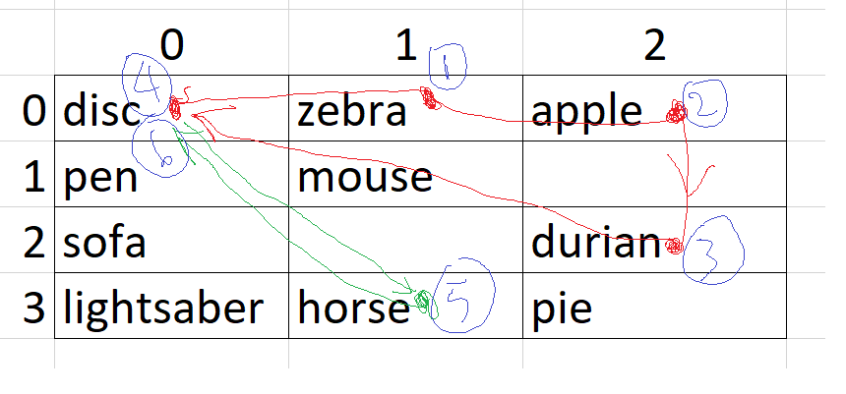
After collecting the 3rd item (durian), the arm moves back to the origin automatically to unload, and then continues to the 4th item (horse). The first collection trip is shown in red, and the second in green.
Total distance moved = d_{(0,0)-(0,1)} + d_{(0,1)-(0,2)} + d_{(0,2)-(2,2)} + d_{(2,2)-(0,0)} + d_{(0,0)-(3,1)} + d_{(3,1)-(0,0)}

e.g. 2:
For the same map, if m is 2, and get_sequence returns ["zebra", "apple", "durian", "horse"], the robotic arm will move like this:
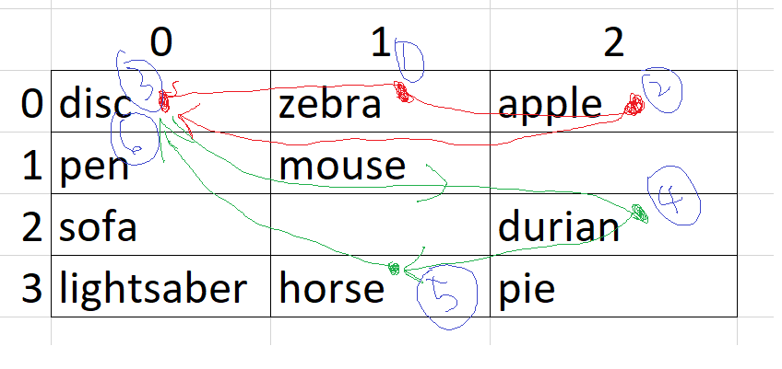
Total distance moved = d_{(0,0)-(0,1)} + d_{(0,1)-(0,2)} + d_{(0,2)-(0,0)} + d _{(0,0)-(2,2)} + d_{(2,2)-(3,1)} + d_{(3,1)-(0,0)}

Files given for Q2:
File name | Description | Comments
p2q2.rb | Contains get_sequence that you will write. | Edit and submit this file.
p2q2_main.rb | Same as Q1
p2_utility.rb
Several m<x>.csv and o<x>.csv files

Q3:
For a second Amazon warehouse that will be built (in Yishun again), three changes are proposed:
- The number of rows for the shelf is fixed at five (because of the low ceiling).
- Your algorithm will decide where items will be placed on the shelf, and
- There will be five robotic arms to improve collection time.
For faster retrieval of items from the shelf, there will be five robotic arms; one for each row. Each arm is only “in charge” of collecting items from its row, and all five arms are fixed permanently to a vertical pole. This vertical pole is programmed to always “sweep” across the shelf: from the left-most column to the right-most column. As the arms move over cells containing items that need to be collected for an order, they will automatically pick up these items. Assume that the “picking up” takes negligible time, and each arm can carry an infinite number of items.
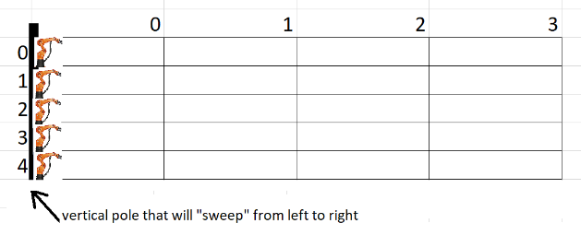
There is no need for the pole to reach the right-most column; once all the items in an order have been collected, the pole stops “sweeping”, and “resets” to the left-most column to unload and gets ready for the next order.

Your algorithm needs to propose the positions of each item on the shelf, so that the vertical pole moves the least horizontal distance when new orders come. Amazon is willing to provide you with historical orders that may be helpful, and you can assume that future orders are somewhat similar in nature to previous ones.

Method to write:
get_layout(historical_orders)
where:
- historical_orders is a 2D array representing previous orders.
e.g. historical_orders = [["disc", "zebra", "apple", "sofa", "kitty", "pen", "mouse", "watermelon"], ["sofa", "hair", "durian", "pen","lightsaber", "horse", "pie", "box", "ox", "cucumber"], ["sausage", "cd", "car", "dracula", "sofa","pen"]]
This represents three historical orders that contain 8, 10 and 6 items respectively. There are 20 unique items in all these three orders (items such as "pen" appear in multiple orders).
Rules:
- get_layout should return your proposed layout of the shelf as a 2D array of item names (strings).
- There must always be five rows in your returned layout, but any number of columns.
- All item names found in historical_orders must be present in your returned layout, and each cell may only contain one type of item.
- There should not be cells that contain identical item names.

e.g. get_layout may return:
[["disc", "zebra", "apple", "kitty", "sausage"], ["pen", "mouse", "watermelon", "cd"], ["sofa", "hair", "durian", "car"], ["lightsaber", "horse", "pie", "dracula"], ["box", "ox", "cucumber"]]
to represent the following layout:
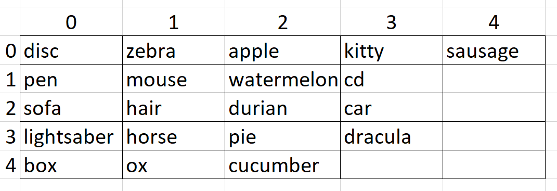
Your quality score will be the total horizontal distance moved by the vertical pole before it completes collecting all the items when a new order comes in (the smaller the better).

e.g.1. using the proposed layout above, if this is the new order:
["pen", "pie", "zebra", "ox", "box"]
the vertical pole will need to move 3 columns to fulfil the order:
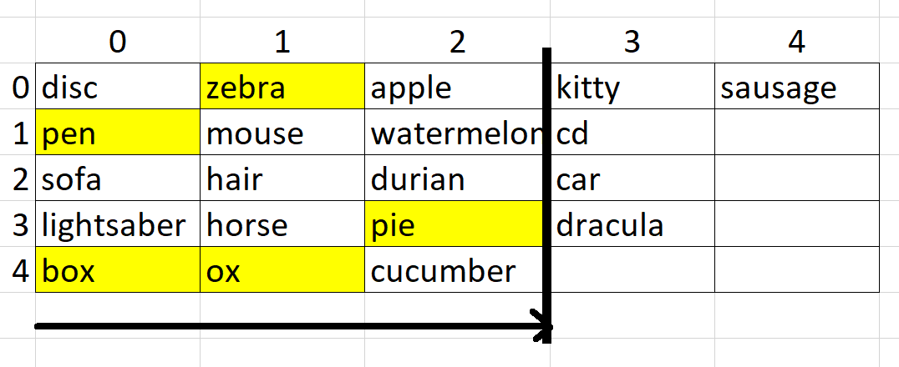
and the quality score will be 3.

e.g.2. using the same proposed layout above, if this is the new order:
["pen", "disc", "box", "sofa", "kitty"]
the vertical pole will need to move 4 columns to fulfil the order:
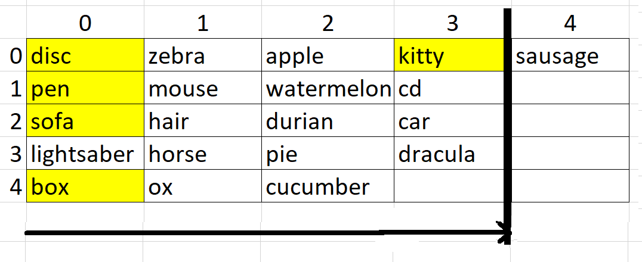
and the quality score will be 4 (poorer).

The new order that will be used to obtain your quality score will not be made known (all you have is historical data – you cannot predict future orders precisely). However, as previously mentioned, you can assume that new orders should be similar in nature to historical orders.

Files given for Q3:
File name | Description | Comments
p2q3.rb | Contains get_layout that you will write. | Edit and submit this file. Do not modify the file name or the method signature.
p2q3_main.rb | Loads p2q3.rb and calls get_layout. | Do not submit this file; use it to check if your get_layout works before submitting it to the server.
p2_utility.rb | Contains methods used by p2q3_main.rb. | Do not submit this file.
Several h<x>.csv files | Contains test cases. Each file represents a series of historical orders.  Format of CSV file: order ID, item ID.  e.g: for h1.csv, the first 8 lines represent a single order with the following 8 items: [B00APE06UA, B00B2G2RG6, B00BLCHYKU,B00F406S2U, B00F4PKH5E, B00H7NDSPC, B00IC9X09O, B00IKT36S6]  q3_read_to_array (in p2_utility.rb) will read this CSV file and return an array of orders automatically. The order ID is irrelevant for this question. |  | Do not submit these files.  Additional test cases may be made available in eLearn soon.

Utility Methods that You May Use:

You are advised to start working using the small test cases when formulating your solution before trying the bigger test cases. You may use the print_2d_array method (in p2_utility.rb) to help you visualize a 2D array.

To submit:
- p1q1.rb, p1q2.rb and p1q3.rb (at server). Include your team ID and names in your code.
- (if any) acknowledgement/reference list (at eLearn dropbox) by deadline.
- (if any) soft copy of materials (e.g. slides) used in your presentation (to eLearn dropbox) immediately AFTER your presentation in week 13.
- Peer appraisal in eLearn after presentation in week 13.

Assessment:
- For code submission:
- Correctness
- Ensure that each solution can run on the server (i.e. you get a quality score on the rank board)
- Time taken to execute on server (the faster the better).
- Quality (the lower the better)
- For Q1/2: calculated as the total distance moved by the robotic arm
- For Q3: calculated as the total horizontal distance moved by the vertical pole
Correctness is the most important factor – if your code cannot run on the server, the server cannot compute the time taken and quality. Do make sure that you have “correct” solutions before improving your algorithms.
Late submissions:
- The server will automatically stop accepting code submissions at 11:30pm sharp on the deadline.
- The time of submission - and not time your code is processed on the server - will be considered your submission time.
- Late submissions must be sent via email to hnmok@smu.edu.sg with 24 hours from the deadline - a penalty of 20% will be imposed.
- Submissions later than 24 hours are not accepted.

- For class presentation:
  - Your Teaching Assistant (TA) will arrange a schedule for your presentation during lesson time on week 13. Please get your schedule from your respective TA.
  - Each team is given 5 minutes to present, and another 5 minutes for Q&A. You may present in any way as long as you adhere strictly to the allocated time. You do NOT need to print any hard copies of the slides for the instructors. You should submit soft copies of materials (including slides) used in your presentation after the presentation.
  - You will be assessed on the (i) clarity, (ii) technical accuracy, and (iii) demonstration of analytical skills.
  - Ensure that every member of your team is clear about all three solutions provided by the team. Questions about a particular solution may be specifically asked to any particular member, even if he is not “in charge” of that solution.

- This assignment is worth 15% of your final grade. Score breakdown:
Item | Marks | Comments
Q1 Code: quality | 2
Q1 Code: time taken | 1
Q2 Code: quality | 2
Q2 Code: time taken | 1
Q3 Code: quality | 4
Q3 Code: time taken | 1
Class presentation | 4
Late submission of code |  | -20% for up to 24 hours late  -100% for >24 hours late.

Have fun! :-)

~ End

